**Active low pass Filter**

**LAB # 10**

** Fall 2019**

**Fall 2021**

**CSE202L Circuit system-II**

Submitted by: **Ashfaq Ahmad**

Registration No: **19PWCSE1795**

Class Section: **B**

“On my honor, as student of University of Engineering and Technology, I have neither given nor received unauthorized assistance on this academic work.”

Student Signature: ______________

Submitted to:

**Engr. Faiz ullah**

February 24 , 2021

**Department of Computer Systems Engineering**

**University of Engineering and Technology, Peshawar**

**Active Filters**

**Theory**

An electric filter is a **frequency-selecting circuit** designed to pass a specified band of frequencies while attenuating (opposite of amplifier mean reduce amplitude of signal) signals of frequencies outside this band. Filters may be either **active or passive** depending on the type of elements used in their circuitry. **Passive filters** contain only **resistors, capacitors, and inductors**. **Active filters employ transistors or op-amps in addition to resistors and capacitors.** Active filters offer several advantages over passive filters. Since the op-amp is capable of providing a gain, the input signal is not attenuated as it is in a passive filter. Because of the high input and low output resistance of the op-amp, the active filter does not cause loading of the source or load. There are four types of filters: **low-pass, high-pass, band-pass, and band-reject filters**. A low-pass filter has a constant gain (=Vout/Vin) from 0 Hz to a **high cut off frequency fH**. This cut off frequency is defined as the frequency where the voltage gain is reduced to 0.707, that is at fH the gain is down by 3 dB; after that (f > fH) gain decreases as f increases. The frequencies between 0 Hz and fH are called **pass band frequencies,** whereas the frequencies beyond fH are the so-called **stop band frequencies**. A common use of a low-pass filter is to remove noise or other unwanted high frequency components in a signal for which you are only interested in the dc or low frequency components. Low-pass filters are also used to avoid aliasing in analog-digital conversion correspondingly, a high-pass filter has a stop band for 0 < f < fL and where fL is the low cut off frequency. A common use for a high-pass filter is to remove the dc component of a signal for which you are only interested in the ac components (such as an audio signal). A band pass filter has a pass band between two cut off frequencies fH and fL, (fH > fL), and two stop bands 0 < f < fL and f > fH. The bandwidth of a band pass filter is equal to fH–fL. The actual response curves of the filters in the stop band either steadily decrease or increase with increase of frequency. The roll-off rate, measured at [dB/decade] or [dB/octave] is defined as rate change of power at 10 times (decade) or 2 times (octave) change of frequency in the stop band. The “First-order” filters attenuate voltages in the stop band 20 dB/decade (for example, a first-order low pass filter would attenuate a signal at a frequency 100 times (2 decades) higher than fH by 40 dB. The second-order filters attenuate by about 40 dB/decade.

**Low Pass Filter**

**Objectives:**

To study the Active Low pass filter and to evaluate:

• High cutoff frequency of Low pass filter.

• Pass band gain of Low pass filter.

• Plot the frequency response of Low pass filter.

**Equipment:**

1. DC power supplies +15V, −15V from external source

2. Function generator

3. Oscilloscope

4. Digital Multimeter

**Components:**

1. Resistance 10kΩ

2. Resistance 22kΩ

3. Capacitor 0.01µF

4. LM 741

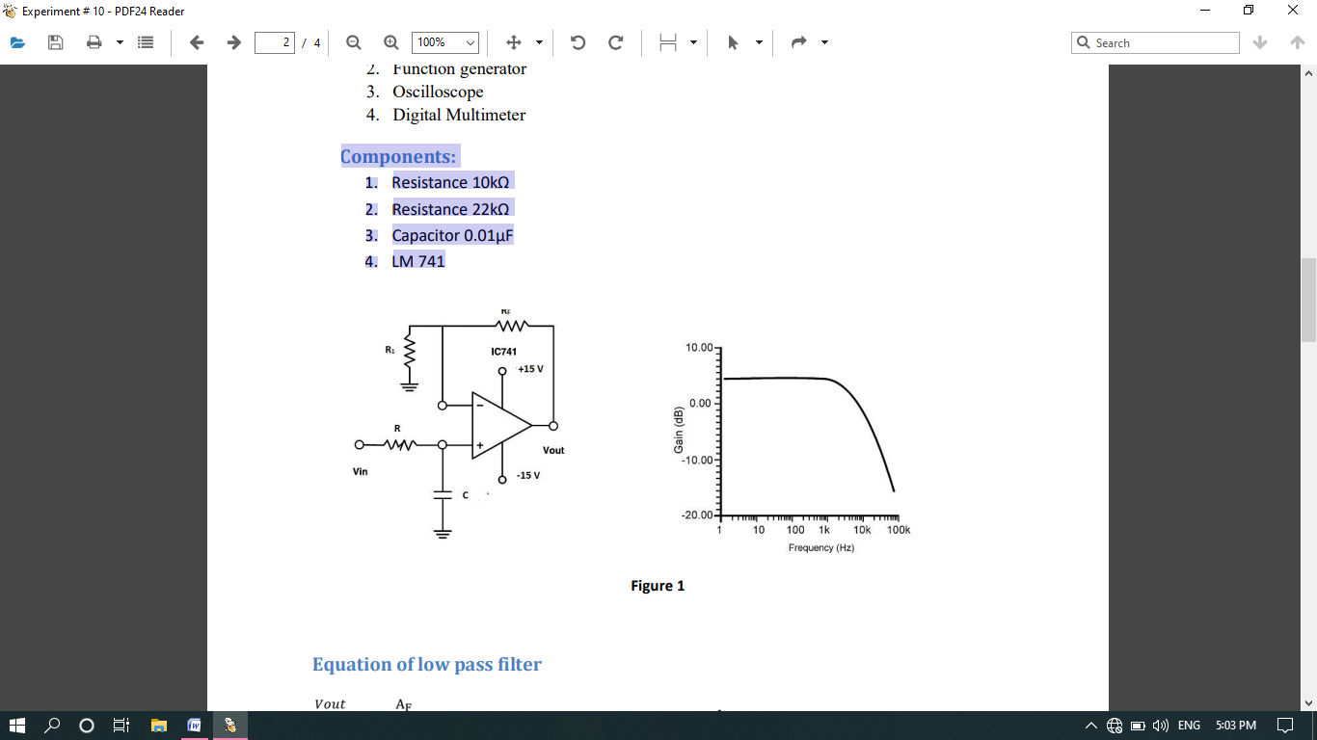

**Equation of low pass filter**

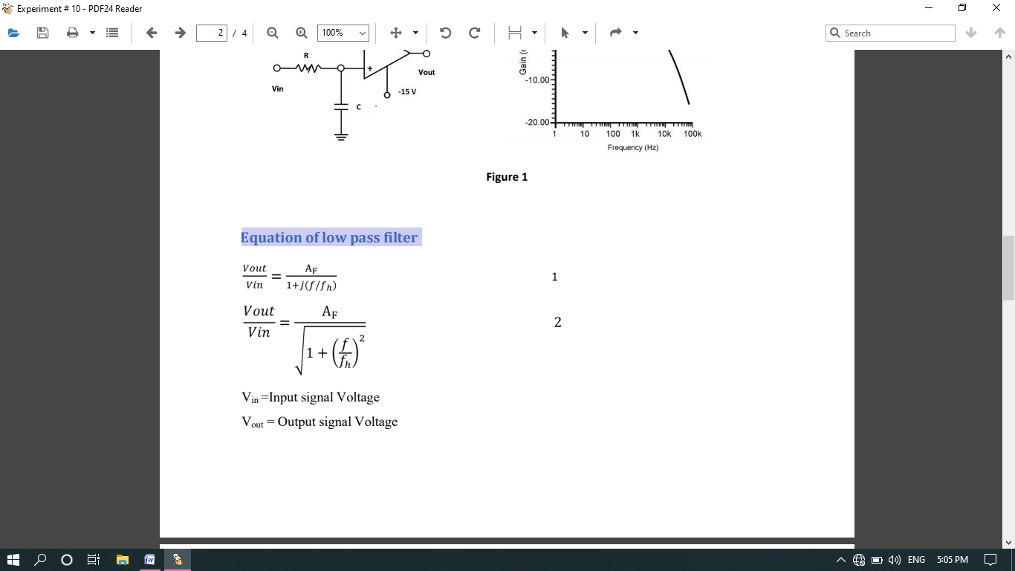

| Vout/Vin |= Gain of filter as a function of frequency

AF =1+RF/R1 = pass band gain of filter

f = frequency of input signal

fH =1/2πRC =high cut off frequency or 3-dB frequency or corner frequency

Operation of low pass filter using equation 2

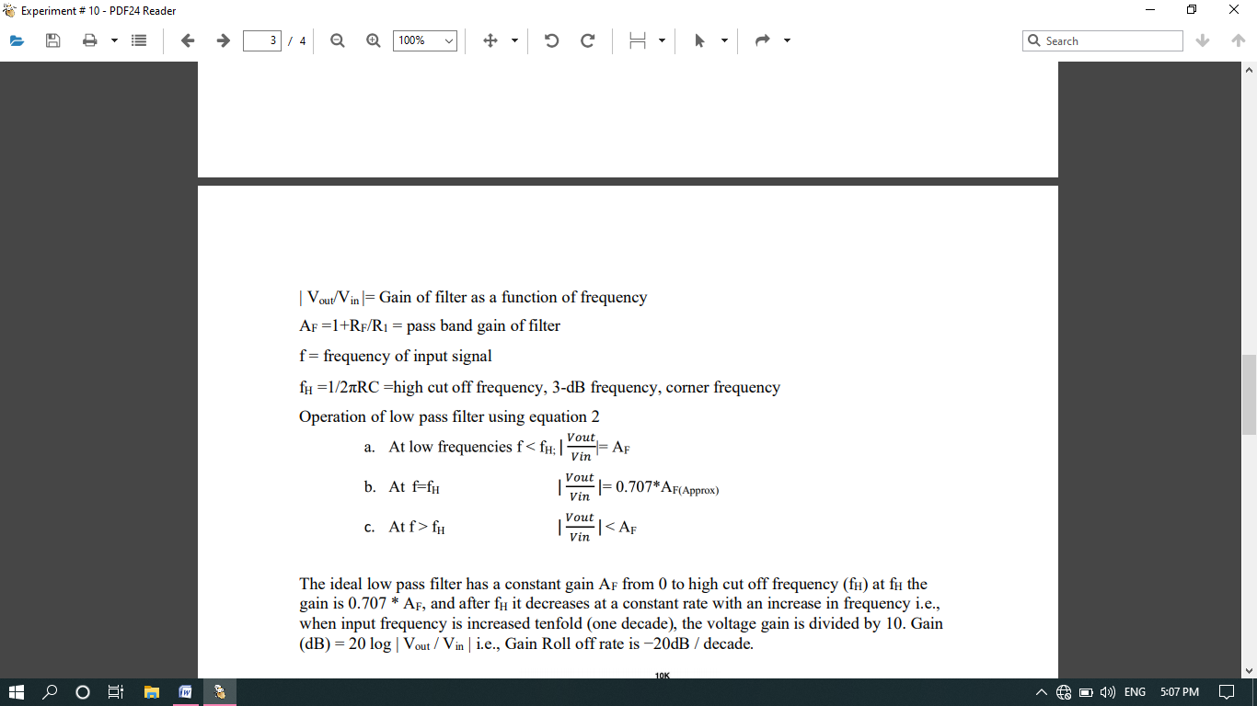

The ideal low pass filter has a constant gain AF from 0 to high cut off frequency (fH) at fH the gain is 0.707 * AF, and after fH gain decreases at a constant rate with an increase in frequency i.e. when input frequency is increased tenfold (one decade), the voltage gain is divided by 10. Gain (dB) = 20 log | Vout / Vin | i.e., Gain Roll off rate is −20dB / decade.

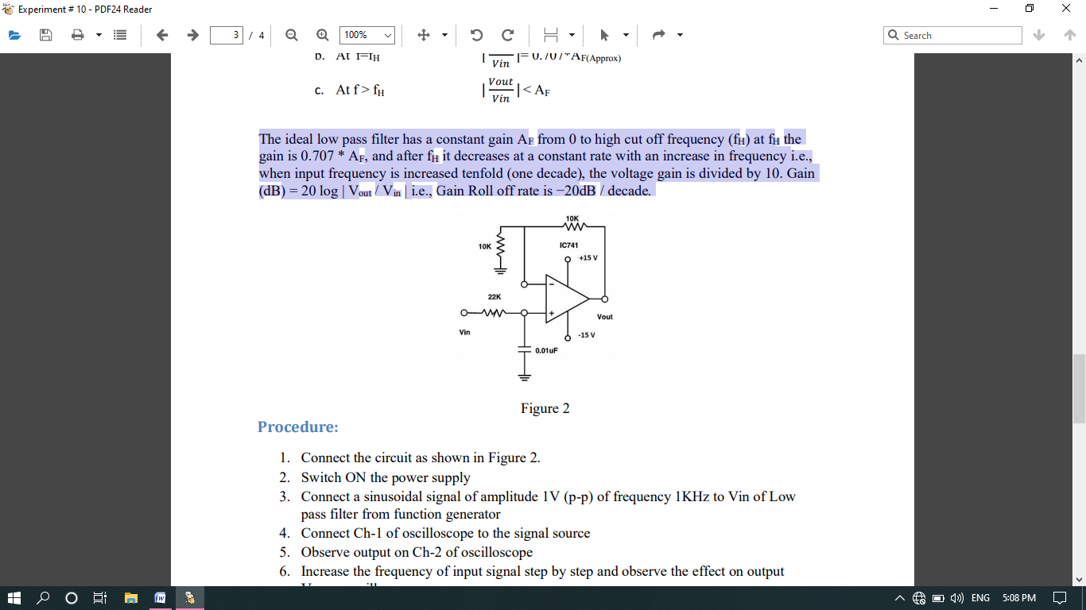

**Procedure:**

1. Connect the circuit as shown in Figure 2.
2. Switch ON the power supply
3. Connect a sinusoidal signal of amplitude 1V (p-p) of frequency 1KHz to Vin of Low pass filter from function generator
4. Connect Ch-1 of oscilloscope to the signal source
5. Observe output on Ch-2 of oscilloscope
6. Increase the frequency of input signal step by step and observe the effect on output Vout on oscilloscope
7. Tabulate values of Vout, gain, gain (dB) at different values of input frequency shown in observation Table 2.
8. Plot the frequency response of low pass filter using the data obtained at different input frequencies.

**Circuit Diagram in proteus:**

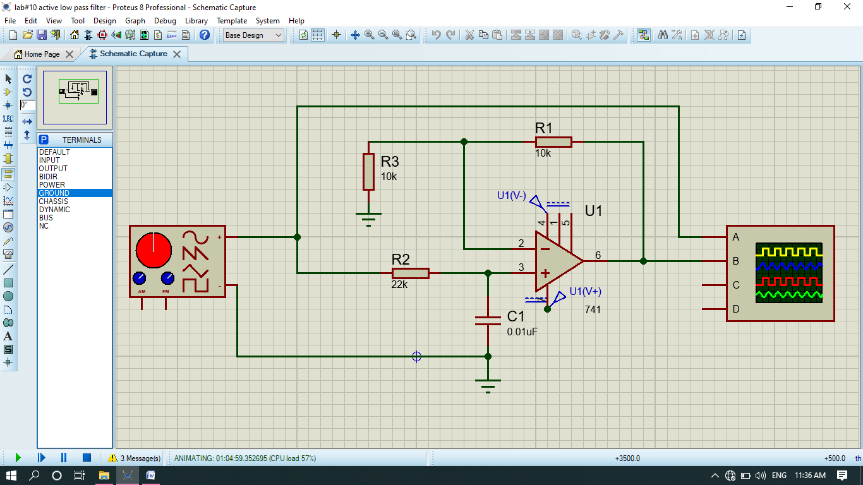

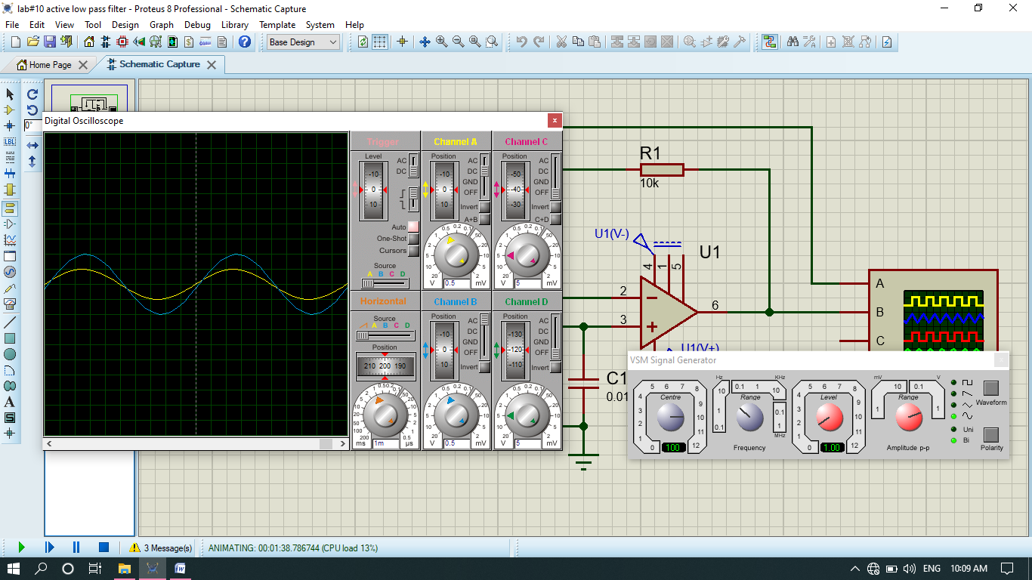

**Theoretical Calculations:**

Calculate all the following values

1. Pass band gain of Low pass filter AF = 1 + RF / R1
2. Pass band gain (dB) = 20 log |Vout / Vin|
3. 3 dB frequency fH = 1/2πRC
4. Gain at 3 dB frequency fH = 0.707 * AF
5. Roll off rate = −20db/decade *//it is constant. If we increase our frequency 10-time then decrease in gain is -20db/decade.*

**Results:**

|  |  |  |
| --- | --- | --- |
|  | theoretical | practical |
| pass band gain (Af) | **2** | **2** |
| pass band gain (Af) in db | **6.02** | **6.02** |
| 3 db frequency fh | **723.43Hz** | **720 Hz** |
| Gain at 3db frequency (fh) in db | **3.0** | **3.0** |

**Table 1**

|  |  |  |  |  |
| --- | --- | --- | --- | --- |
| S No | Input frequency (Hz) | Vout | |Vout/vin|=Gain | Gain (db)=20 log |vout/vin| |
| 1 | **300** | **4.7** | **0.94** | **-0.537** |
| 2 | **500** | **2.05** | **0.41** | **-7.74** |
| 3 | **700** | **7.1** | **1.42** | **3.046** |
| 4 | **1k** | **5.8** | **1.16** | **1.29** |
| 5 | **5k** | **1.5** | **0.3** | **-10.46** |
| 6 | **10k** | **0.7** | **0.14** | **-17.07** |
| 7 | **15k** | **0.48** | **0.096** | **-20.35** |

**Table 2**

**THE END**